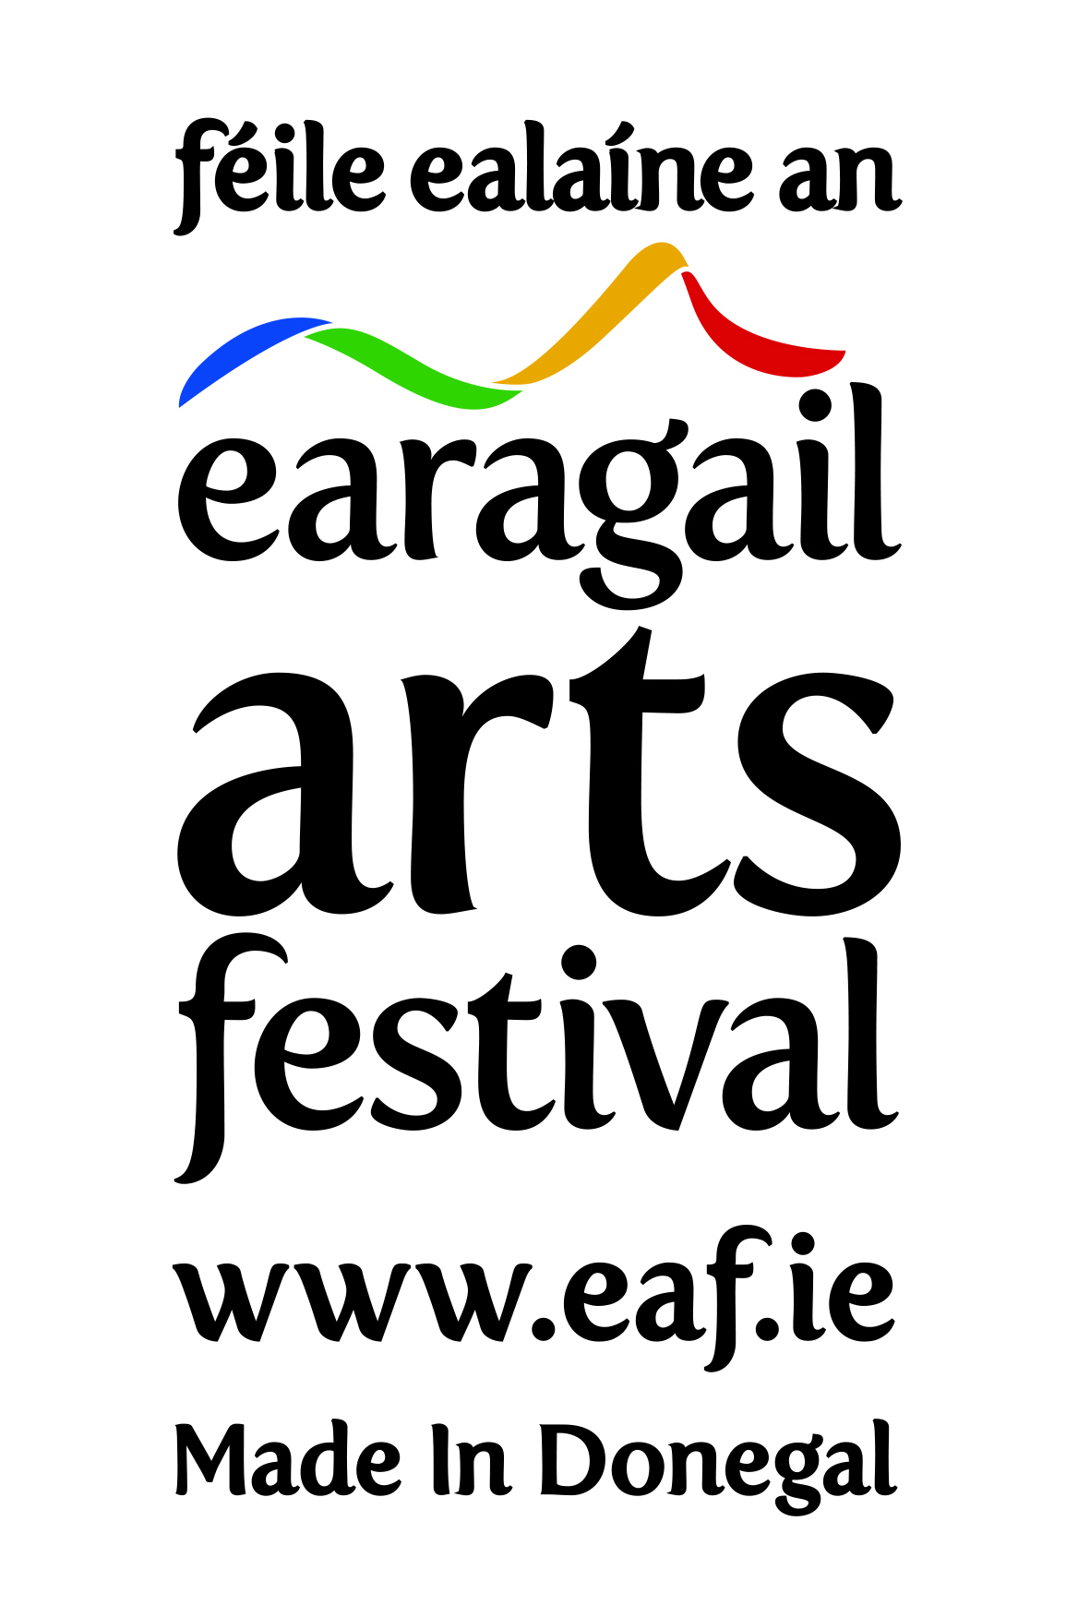
Volunteers Co-ordinator (Contract for services)

Earagail Arts Festival is seeking proposals for the provision of a contract for services of a Volunteers & Outreach Co-ordinator for the period 27th May 2024 – 31st July 2024.

Introduction

Earagail Arts Festival

Earagail Arts Festival is Donegal’s premier celebration of local, national and international culture and one of the largest arts festivals in Ireland. Over 40,000 people from across Donegal and around the world attend approximately 100 events in 35 venues spread over 19 towns over 16 days and nights across the North West of Ireland.

Earagail Arts Festival Management Company Limited is a not-for profit CLG and a registered charity. The Festival consists of a Board of Directors, Management Committee, full time, part time, contract staff and volunteers. The Festival celebrates its 37th birthday between the 13th and 28th July 2024.
The Festival’s objectives are synonymous with those of its major funders, addressing the key propositions of the Arts Council’s 10-year strategy - Making Great Art Work: Leading the Development of the Arts in Ireland (2016–2025) and Failte Ireland’s Wild Atlantic Way.

Terms

The task will entail working for a number of hours per week, over the period 27th May 2024 – 31st July 2024. 39 Days required.

The contractors’ duties will be primarily carried out at the offices of the Earagail Arts Festival Management Company Limited.

Budget

The remuneration for this post is €4,500 before taxes. Volunteers Co-ordinator to invoice Earagail Arts Festival accordingly.

Responsibilities

The main focus of this appointment is the recruitment and management of volunteers in accordance with the festival’s Equality, Diversity and Inclusion Policy, including:
- Promoting volunteering (internally and externally) through recruitment and publicity strategies, profile-raising events and campaigns.
- Organising rotas and providing inductions and training for tutors and volunteers.
- Monitoring, supporting, motivating and accrediting volunteers and their work.
- Attending committees and meetings.
- Managing budgets and resources, including the reimbursement of expenses.
- Keeping up to date with legislation and policy related to volunteering and making any necessary modifications to accommodate changes.
- Monitoring and evaluating activities and writing reports for funders and trustees.
- Maintaining databases and undertaking any other administrative duties.
Experience

The ideal appointee will:

- have 3 years experience of working in a volunteer management and/or arts facilitation role;
- be prepared to work unsociable hours at festival time;
- be used to working in a busy and pressured working environment;
- be enthusiastic and flexible.

Irish language

Proficiency in the Irish Language would be advantageous.

Driving Licence

Full, clean driving licence and use of own vehicle required.

Please include an up-to-date CV, including the names of two previous or current clients whom we may contact, should we wish to offer you this contract.

Earagail Arts Festival welcomes proposals for the provision for services of a Volunteers Co-ordinator of the Earagail Arts Festival 2024 as outlined above, on or before 5.00pm on Thursday 16th May 2024. Please submit your proposal by email to: info@eaf.ie or in writing by CV and cover letter to:

Earagail Arts Festival
2c Riverside Office Park
Neil T Blaney
Letterkenny
Co Donegal
F92 YN40

