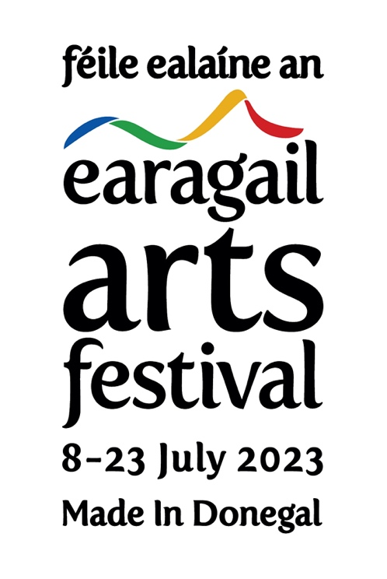
HOME WITH THE HENRY GIRLS
17-21 JULY 2023
RESIDENCY BURSARY APPLICATION FORM
D.O.B:
NAME:
ADDRESS:
________________________________________________________________
________________________________________________________________
________________________________________________________________

EMAIL:
PHONE NUMBER:
_________________________________

What experience do you have with songwriting/singing/playing an instrument?
______________________________________________________________________________________________________________________________________________________________________________________________________________________________________________________
Sponsored residency places are offered to participants who might otherwise be unable to attend due to a variety of reasons including, but not limited to, financial constraints and associated costs of travel, childcare or accommodation. The Earagail Arts Festival is committed to supporting the inclusion and skills development of people from different ethnic backgrounds, people with a disability and those from rural communities.

Please outline briefly how you would benefit from a sponsored place on the residency.

_____________________________________________________________________________________________________________________________________________________________________________________________________________________________________________________

Are you a member/service user of an organisation that informed you about the residency?
If so, please state the organisation name ________________________________________________

Signed:

Date:

N.B. Suitable for ages 16+ (under 18's must be accompanied by an adult for the duration of the bursary).

