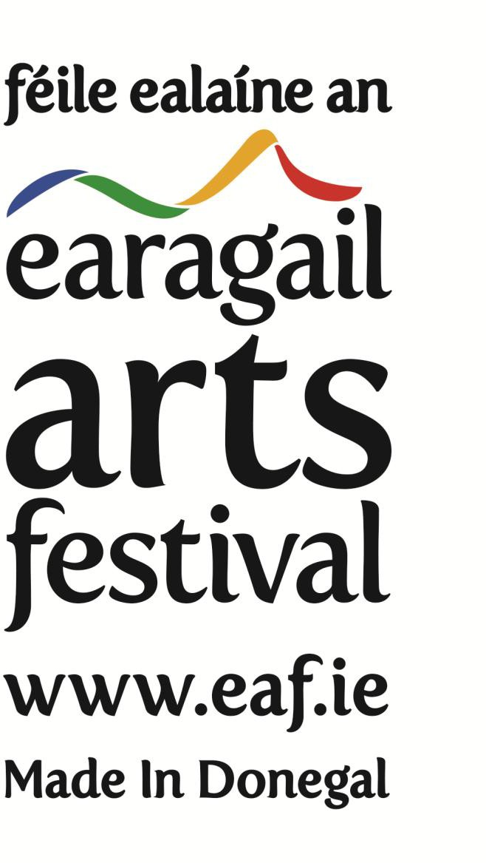

Equality, Diversity & Inclusion Policy Consultant (contract for services)

Earagail Arts Festival Management Company CLG is seeking proposals for the provision of a contract for services of an Equality, Diversity & Inclusion Policy Consultant.

Introduction

Earagail Arts Festival

Earagail Arts Festival is Donegal’s premier celebration of local, national and international culture and one of the largest arts festivals in Ireland. Over 40,000 people from across Donegal and around the world attend approximately 100 events in 35 venues spread over 19 towns over 16 days and nights across the North West of Ireland. Earagail Arts Festival Management Company Limited is a not-for profit CLG and a registered charity. The Festival consists of a Board of Directors, Management Committee, full time, part time, contract staff and volunteers. The Festival celebrated its 35th birthday between 9th and 24th July 2022.

Earagail Arts Festival seeks support to develop it’s methods of increasing inclusivity across all areas of society; to facilitate deeper public engagement with audiences in general and specifically to target groups in arts and disability, young people, minority ethnic groups and economically disadvantaged families, particularly in areas of low arts engagement. The EDI consultant will be employed to carry out external and internal consultation with staff and stakeholders, in the context of current legislation and compliance.

Terms

The Equality, Diversity & Inclusion Consultant role is relevant to the Earagail Arts Festival. While it is envisaged that the Equality, Diversity & Inclusion Consultant may work mainly from their own workspace, the task will require the successful provider to allow for meetings in Donegal, with staff, board and stakeholders.

Budget

The maximum Budget for the delivery of this Service is €6,000 (including VAT if applicable, travel and other expenses).

The Role

Earagail Arts Festival would like to engage an external consultant specialising in Equality, Diversity and Inclusion policy development that will assist in building and developing inclusivity and in turn provide the necessary support, skills and expertise to review and adapt the organisation’s artistic and business model and support strategic development in the medium to long term. The role will report to the EAF CEO /Artistic Director and Chair of the Board of Directors.

Experience

The ideal candidate will have a proven track record in Equality, Diversity & Inclusion policy development.

Irish language

Proficiency in the Irish Language would be advantageous.

Selection Criteria

In the selection of the Equality, Diversity & Inclusion Consultant, the following criteria will apply and will be weighted accordingly -

Equality, Diversity & Inclusion Policy Development Experience | 50%
Arts Consultancy Experience | 35%
Price Quoted | 10%
Irish Language Proficiency | 5%

Submission of Proposal

Your proposal should outline your experience in terms of the delivery of similar projects to-date and include an overall costing for the delivery of the service. Please include any additional information that you consider is relevant to your proposed delivery of this service. Please also include an up-to-date CV, including the names of two referees or previous or current clients whom we may contact, should we wish to offer you this contract.

Earagail Arts Festival welcomes proposals for the provision of the services of a Equality, Diversity & Inclusion Consultant as outlined above, on or before 5.00pm on Friday, 11th November 2022. Please submit your proposal by email to director@eaf.ie or in writing to:

CEO / Artistic Director Earagail Arts Festival 2c Riverside
Neil T Blaney Letterkenny Co Donegal F92 YN40

